# Folder Comparison Tool

## The tool and its purpose:

Folder comparer is a tool that allows the user to view through two different directories within the user’s machine.

The tool’s purpose is to allow users to spot differences between the files and folders within one directory, relative to another. The tool will highlight these in different colour in order to allow the user to see the difference clearly.

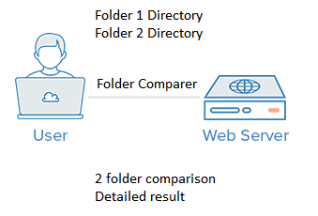

## Requirements:

* Be able to browse to 2 different folders
* Be able to highlight differences
* Know total file size and number of files
* Able to use a reset button for the tool

Using name, content and date modification, the tool will allow you to see what files are the same, what files are not the same, what files have the same content with different names and also what files have different content with the same name.

## Technology used:

* ASP.NET
* MVC

The technology used in order to meet pre-built requirement were application server pages (ASP.NET) in order to create a web application.

In order to structure the application more effectively, model view controller (MVC) was also used in order to enhance user experience. No database connection was needed.

## Requirements met:

Folder comparer was able to meet the following requirements:

* Be able to browse to 2 different folders
* Be able to highlight differences
* Know total file size and number of files
* Able to use a reset button for the tool

I was able to browse different folders by allowing to textbox input’s available for the user. I was able to highlight differences by using html tables to alter the background of a file.

Total file size and number of files was displayed at the bottom of the page and a reset button available also

## Outcome:

The user had been pleased with the result of folder comparer and had recommended a suggestion that had been completed.

The tool is also available for the internal team to use by accessing the team foundation server (TFS).

This allows the project to be accessed by an internal member and allow them to use or deploy to local internet information services (IIS) and run the tool at their disposal.